**SPECTROSCOPY AND ELECTRO-ANALYTICAL TECHNIQUES**

**SPECTROSCOPY**

**UV-Visible spectroscopy**

**The Electromagnetic Spectrum**

The visible spectrum constitutes but a small part of the total radiation spectrum. Most of the radiation that surrounds us cannot be seen, but can be detected by dedicated sensing instruments. This electromagnetic spectrum ranges from very short wavelengths (including gamma and x-rays) to very long wavelengths (including microwaves and broadcast radio waves). The following chart displays many of the important regions of this spectrum, and demonstrates the inverse relationship between wavelength and frequency (shown in the top equation below the chart).

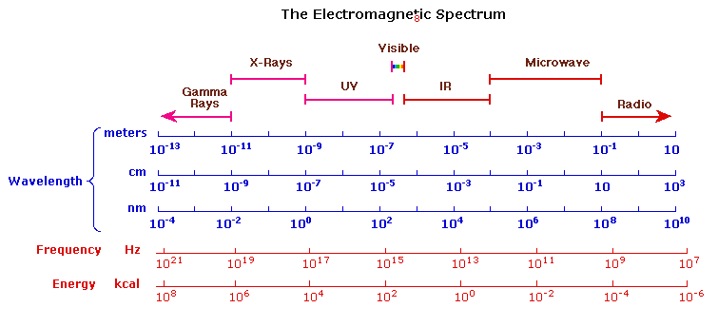

The energy associated with a given segment of the spectrum is proportional to its frequency. The bottom equation describes this relationship, which provides the energy carried by a photon of a given wavelength of radiation.



**Electronic Transition: (Self Study)**

The visible region of the spectrum comprises photon energies of 36 to 72 kcal/mole, and the near ultraviolet region, out to 200 nm, extends this energy range to 143 kcal/mole. Ultraviolet radiation having wavelengths less than 200 nm is difficult to handle, and is seldom used as a routine tool for structural analysis.

The energies noted above are sufficient to promote or excite a molecular electron to a higher energy orbital. Consequently, absorption spectroscopy carried out in this region is sometimes called "electronic spectroscopy".

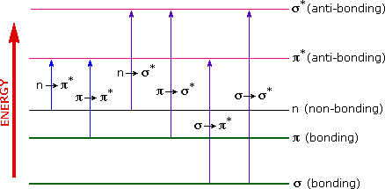

A diagram showing the various kinds of electronic excitation that may occur in organic molecules is shown above. Of the six transitions outlined, only the two lowest energy ones (left-most, colored blue) are achieved by the energies available in the 200 to 800 nm spectrum. As a rule, energetically favored electron promotion will be from the highest occupied molecular orbital (HOMO) to the lowest unoccupied molecular orbital (LUMO), and the resulting species is called an excited state.

When sample molecules are exposed to light having an energy that matches a possible electronic transition within the molecule, some of the light energy will be absorbed as the electron is promoted to a higher energy orbital. An optical spectrometer records the wavelengths at which absorption occurs, together with the degree of absorption at each wavelength. The resulting spectrum is presented as a graph of absorbance (A) versus wavelength.

When a beam of light passes through an absorbing medium, for example a solution, a part of the light is absorbed and the rest is transmitted. The amount of light absorbed depends on the concentration of the solution and the length traversed by the light through the solution. The quantitative relation between the amount of light absorbed, concentration and the length of the absorbing medium is governed by the laws- the Lambert’s Law, the Beer’s Law.

**Lambert’s Law:**

**The law states that “Equal fractions of the incident light are absorbed by successive layers of equal thickness of the absorbing medium”.**

If a monochromatic light passes through a transparent medium, the rate of decrease in intensity with the thickness of medium is proportional to intensity of the incident light i.e.

-dI/I α dl

dI/I = - k1 dl-------(i)

Where- I is intensity of the incident light of wavelength λ, l is the thickness of the medium and k1 is proportionality factor. The negative sign indicates that due to absorption, the intensity of light decreases as it passes through the absorbing medium.

If I0 is the initial intensity of incident light on the absorbing medium of length l and It is the intensity of transmitted beam, then the integration of eqn.(i) becomes

ln(It / Io) = - k1 .l

ln(Io/ It) = k1 .l

log10(Io/ It) = k1  x l

2.303-----------(ii)

**Beer’s Law:**

**The law states that “Equal fractions of the incident light are absorbed by successive layers having equal concentration of the absorbing medium”.**

The intensity of a beam of monochromatic light decreases exponentially as the concentration of the absorbing substance increases arithmetically.i.e.

-dI/I α dc

dI/I = - k2 dc ------(iii)

If I0 is the initial intensity of incident light on the absorbing medium of concentration c and It is the intensity of transmitted beam, then the integration of eqn.(iii) becomes

ln(It / Io) = - k2 .c

ln(Io/ It) = k2 .c

log10(Io/ It) = k2  x c

2.303-----------(iv)

**Beer-Lambert’s law:**

**A combination of Lambert’s Law and Beer’s Law results in Beer-Lambert’s Law, it states that “Equal fractions of the incident light are absorbed by successive layers of equal thickness and equal concentration of the absorbing medium.”**

Combining (ii) and (iv),

log10(Io/ It) = k x c x l

2.303

log10(Io/It) = ε c l

Log(Io/It) is called as absorbance, if c is expressed in mol dm-3 and l in cm then ε is called as molar absorptivity or absorption coefficient.

Hence, A = ε c l = log(Io/It) = log (1/T) = -log(T) where T is transmittance.

**Conditions:** The law is only true for monochromatic light, which is light of a single wavelength or narrow band of wavelengths, and provided that the physical or chemical state of the substance does not change with concentration.



Io is the intensity of the incident radiation and I is the intensity of the transmitted radiation. The ratio I/Io is called transmittance. This is sometimes expressed as a percentage and referred to as %transmittance.

Mathematically, absorbance is related to percentage transmittance T by the expression:

A = log10(Io/I) = log10(100/T) = ε x c x L

where L is the length of the radiation path through the sample, c is the concentration of absorbing molecules in that path, and ε is the molar extinction coefficient - a constant dependent only on the nature of the molecule and the wavelength of the radiation. If concentration is expressed in mol/dm3 and L is expressed in dm then unit for  is dm2/mol.





**Limitations of the Beer-Lambert law**

1. The linear relationship between absorbance and concentration of solution is not observed at concentration above 10-2 M, hence concentrated solution do not obey Beer-Lambert’s Law.
2. The law does not obeyed if the absorbing species reacts with the solvent, dissociates or associates in solution. The molecules of the absorbing species should remain as simple molecules and should not undergo any change in molecular condition.
3. The light incident on the absorbing medium should be monochromatic otherwise minor deviations from Beer-Lambert’s Law are observed. Hence monochromators have to be used to produce monochromatic beams.
4. The molar absorptivity depends on the refractive index of the absorbing medium. The refractive index changes with the concentration of the absorbing medium. At high concentration these changes are considerable but at concentrations below 10-2 M, these changes can be neglected.
5. Temperature fluctuations and entry of stray light into the absorbing system also lead to deviations from Beer-Lambert’s law.
6. The Fluoresecence or phosphorescence can cause a positive deviation in % T and negative deviation for A in the system.
7. Non-monochromatic radiation, deviations can be minimized by using a relatively flat part of the absorption spectrum such as the maximum of an absorption band.

**Numericals:**

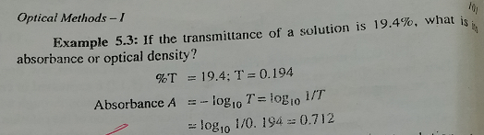

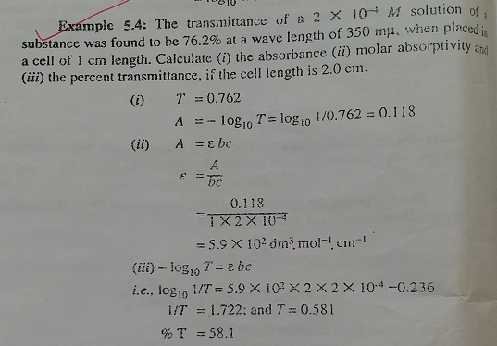

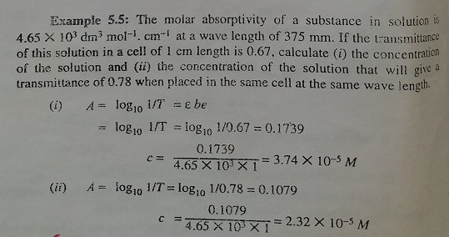

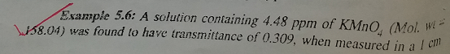

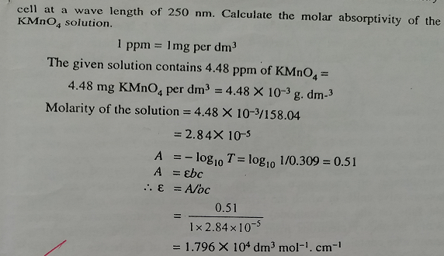

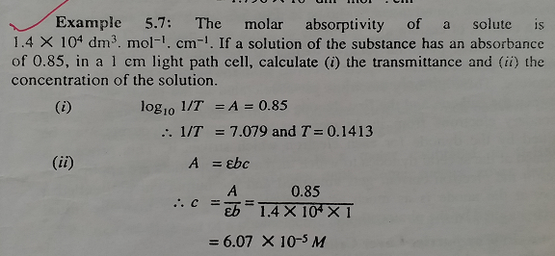

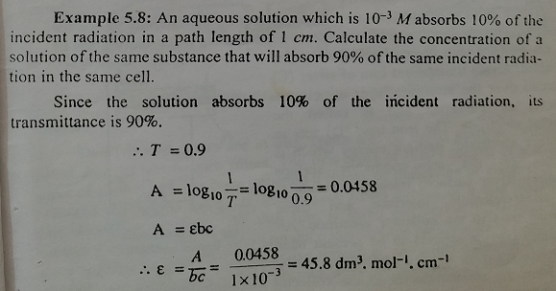

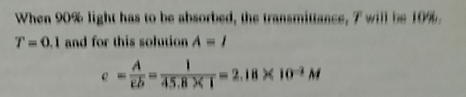

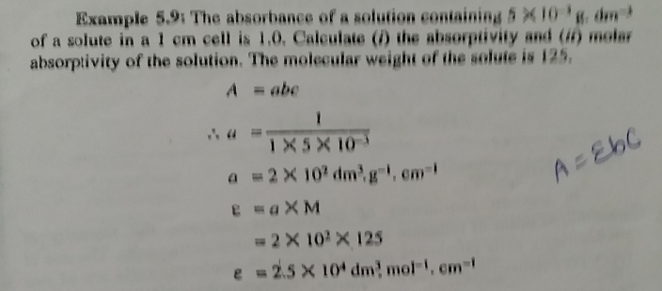

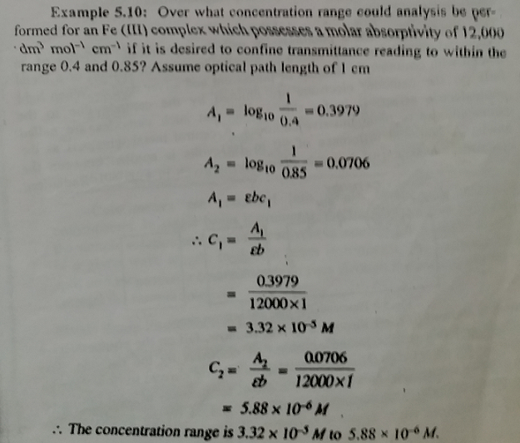

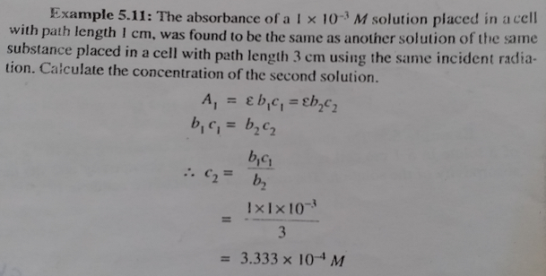

## Ultraviolet-visible spectrophotometer

Generally carried in 200- 700nm region because below 200nm oxygen absorbs strongly. Below 200nm analysis can be done using Nitrogen (in vacuum).

The instrument used in ultraviolet-visible spectroscopy is called a UV/Vis spectrophotometer. It measures the intensity of light passing through a sample (I), and compares it to the intensity of light before it passes through the sample (Io). The ratio I/Io is called the transmittance, and is usually expressed as a percentage (%T). The absorbance, A, is based on the transmittance:



The UV-visible spectrophotometer can also be configured to measure reflectance. In this case, the spectrophotometer measures the intensity of light reflected from a sample (I), and compares it to the intensity of light reflected from a reference material (Io) (such as a white tile). The ratio I/Io is called the reflectance, and is usually expressed as a percentage (%R).

The basic parts of a spectrophotometer are a light source, a holder for the sample, a diffraction grating in a monochromator or a prism to separate the different wavelengths of light, and a detector.

**Single beam spectrophotometer**

A single beam spectrophotometer is comprised of a light source, a monochromator, a sample holder, and a detector. An ideal instrument has a light source that emits with equal intensity at all wavelengths, a monochromator that is equally efficient in splitting light into narrow groups of wavelength for all wavelengths, and a detector that is sensitive and responds equally to all wavelengths.



**Light sources**

Because no single light source with the appropriate characteristics exists, most spectrophotometers use two lamps, with one for the ultraviolet region and one for the visible region. The visible lamp is usually a tungsten lamp (300-2500 nm), while the ultraviolet lamp is a deuterium lamp (190-400 nm). An alternative, relatively rarely used in spectrophotometers, although commonly used in other types of spectroscopic instruments, is a xenon arc lamp (160-2,000 nm).

**Monochromators**

Although prisms can be used as monochromators, most instruments use diffraction gratings. Light shining on the closely spaced grooves of a diffraction grating at an angle is separated into different wavelengths in a consistent manner, assuming that the grooves are consistently produced.

**Detector**

The detector is typically a photomultiplier tube, a photodiode, a photodiode array or a charge-coupled device (CCD). Single photodiode detectors and photomultiplier tubes are used with scanning monochromators, which filter the light so that only light of a single wavelength reaches the detector at one time. The scanning monochromator moves the diffraction grating to "step-through" each wavelength so that its intensity may be measured as a function of wavelength. Fixed monochromators are used with CCDs and photodiode arrays. As both of these devices consist of many detectors grouped into one or two dimensional arrays, they are able to collect light of different wavelengths on different pixels or groups of pixels simultaneously.

The most commonly used detector is a photomultiplier tube (PMT). An incoming photon hits a thin metal film inside a vacuum tube. The metal film is maintained at a large negative potential, and emits electrons. These collide with a series of dynodes maintained at progressively lower potentials; each dynode emits several electrons in response to each incoming electron, resulting in a large amplification of the signal. Because the initial photon is required to initiate the process, most PMTs have very little dark current (“dark current” is signal without light). Proper functioning of a PMT requires a constant voltage across the PMT; maintaining a constant voltage in the face of a high signal requires a well-designed instrument. PMTs are wavelength dependent, with the degree of dependence being related to the metal used in the thin film; most PMTs exhibit the greatest sensitivity at ~400 nm.

An alternative type of detector uses photodiodes. Photodiodes are inexpensive but not very sensitive. Their low cost has allowed arrays of photodiodes to be set up to allow simultaneous detection of many wavelengths. In this type of spectrophotometer, the monochromator is located after the sample, so that it splits the multiwavelength light leaving the sample.

A charge coupled device (CCD) is a sensitive array detector. CCDs store charges released in response to photon impacts. Because the stored charges are stable for prolonged periods, a CCD can collect data for considerable time prior to readout of the signal. They are therefore potentially extremely sensitive. They will probably displace PMTs from some uses as their price decreases. CCDs are used in digital cameras and other consumer products and are rapidly becoming less expensive as a result of both economies of scale and the development of improved production techniques.

**Cuvettes (Sample Holder)**

Most samples studied using visible and ultraviolet spectroscopies are liquid. The sample must therefore be placed in a transparent container to allow measurement. These containers are called cuvettes. Cuvettes are generally made from transparent plastic, glass, or quartz. Different cuvettes have different optical properties.

**Working**: The sample holder is filled with the solvent (blank). The absorbance value of the solvent is adjusted to zero for a particular wavelength, obtained by the rotation of the monochromator. The sample is then taken in the sample holder and its absorbance value is determined for the same wavelength. The procedure is repeated for different wavelengths obtained by the rotation of the monochromator. The absorbance values can be read either on a dial or a digital display. The λmax values for the sample can be thus found.

**Double Beam Spectrophotometer**

A beam of visible light from an incandescent tungsten lamp passes through a colour filter which selects a narrow band of wavelengths. A mirror splits this narrow band into two beams-one passing through the sample and the other passing through the solvent (blank) hence the name Double beam Spectrophotometer.

The sample absorbs a part of beam whereas the solvent transmits it completely. The two beams then fall on the respective photocells, where photoelectrons are emitted and recorded.

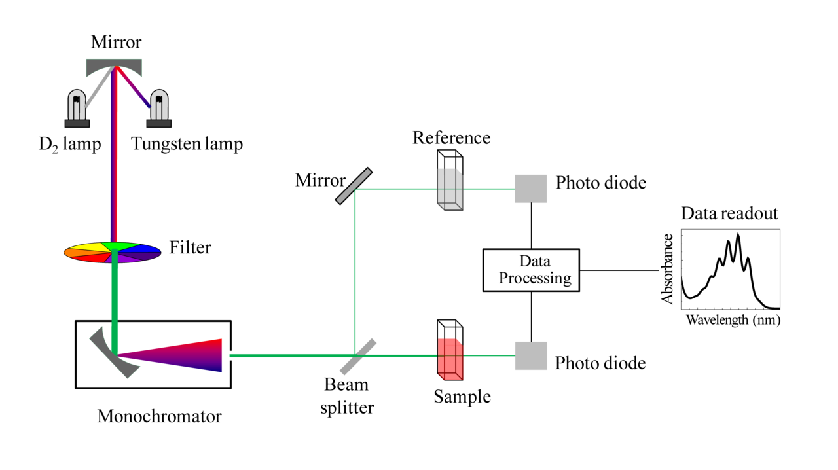

**Working:** The solvent is first taken in both cuvettes, and zero level adjusted. The sample is then placed in the sample cuvette. It absorbs a part of the light and the transmitted beam emerging from it falls on the photodiode. This beam has less intensity than when only solvent was present in the sample cuvette. Hence there will be proportionate decrease in the electric current produced in photodiode and recorded.

**Advantages of Double beam spectrophotometer over single beam spectrophotometer:**

1. Changes in the intensity incident light due voltage fluctuations in the power supply are compensated by splitting the incident beam into identical beams by the use of a mirror and two balanced photodiodes. Any error due to solvent or impurity is balanced out as identical beams pass through the blank and sample as the absorbance of blank is initially adjusted to zero.
2. The readings are not affected by changes in sensitivity of photodiodes as the zero method is used.
3. The scale of instrument is linear with the concentration of the sample solution.

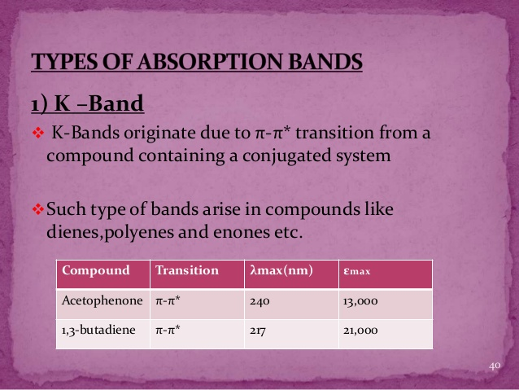

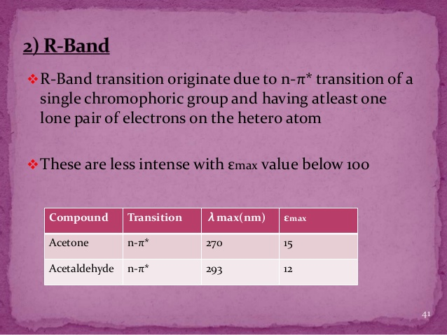

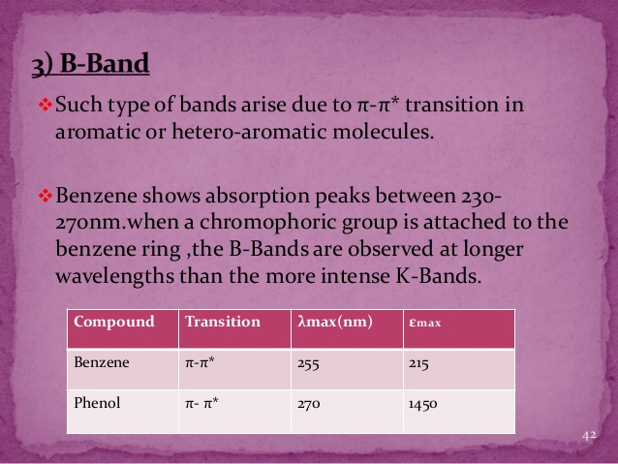

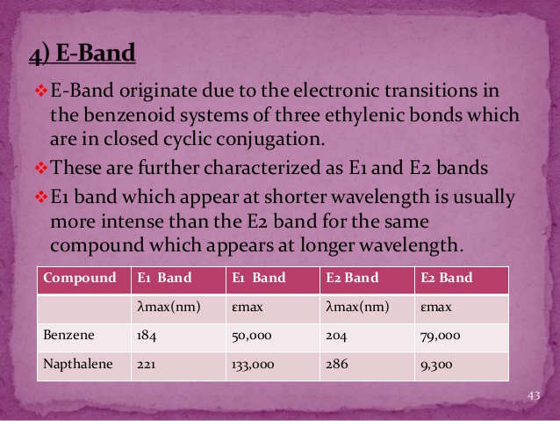

**Absorption and Intensity Shifts:**

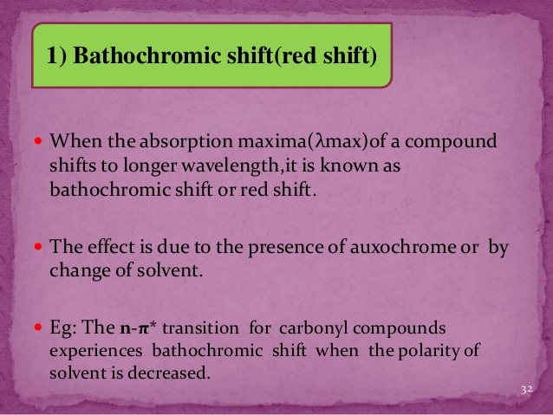

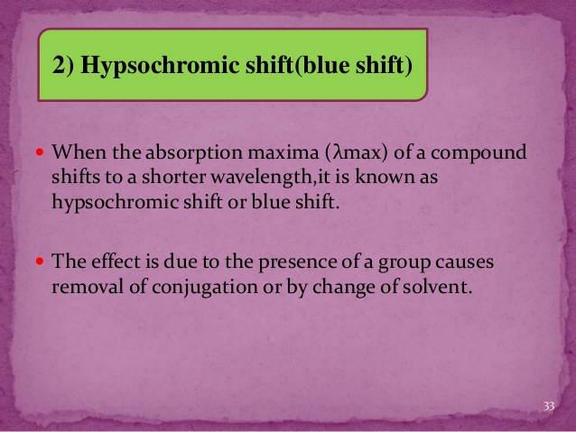

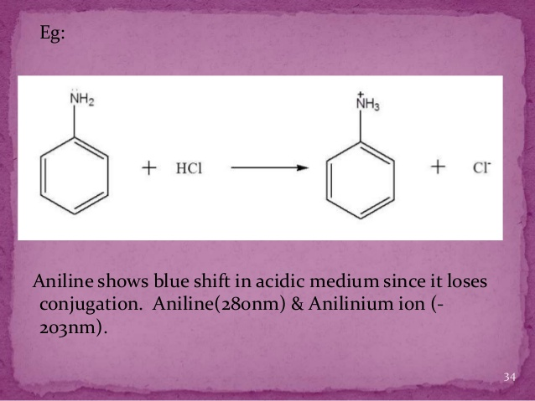

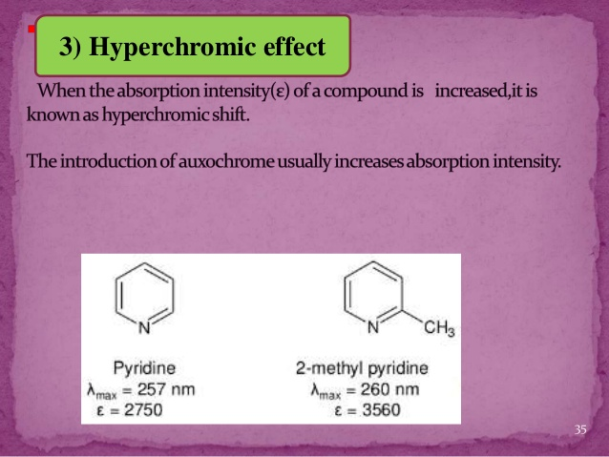

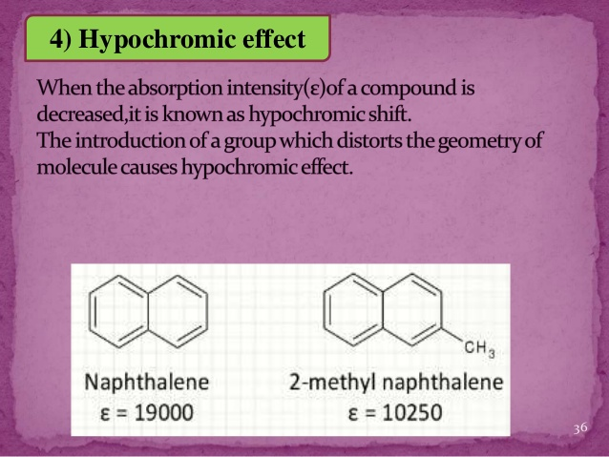

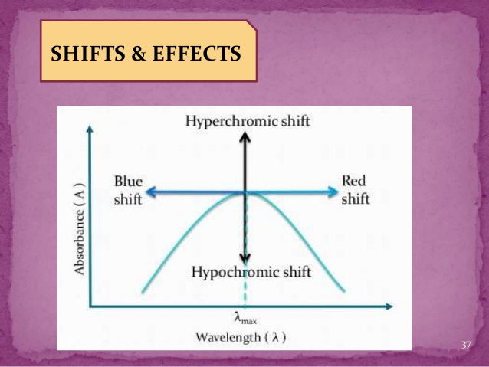

**Applications:**

1. **Determination of λmax and identifying the functional groups:** It is possible to identify a particular group in a molecule by determining its λmax value. In spectrophotometers, the beams of characteristic wavelength are produced; these are absorbed by sample, which are indicative of functional groups as different functional groups in the molecule absorb their own λmax values.

|  |  |  |  |
| --- | --- | --- | --- |
| Function group | Example | λmax in nm | Solvent |
| -COOH | Acetic acid | 208 | Ethyl alcohol |
| -COCl | Acetyl chloride | 220 | Hexane |
| -CONH2 | Acetamide | 178 | Hexane |
| -NO2 | Nitromethane | 201 | Methyl alcohol |

1. **Quantitative Analysis (Calibration curve method):** UV/Vis spectroscopy is routinely used in analytical chemistry for the quantitative determination of different analytes, such as transition metal ions, highly conjugated organic compounds, and biological macromolecules. Spectroscopic analysis is commonly carried out in solutions but solids and gases may also be studied.

In this, a series of solutions of different concentrations of the compound is prepared. Usually the concentrations vary from 10-3 M to 10-2 M. The absorbance is then determined for these standard solutions at the wavelength which absorbed maximally by the coloured compound (λmax). A graph of absorbance versus the concentration is then plotted.

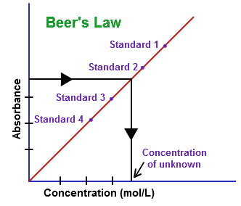

From the calibration curve the concentration of the unknown solution can be found out as shown.

1. **Photometric titrations:** Spectrophotometric measurements can be employed to advantage in locating the equivalence point of a titration, provided the analyte, reagent or titration product absorbs radiation. Alternatively absorbing indicator can provide the absorbance change necessary for the location of equivalence point.
2. A UV/Vis spectrophotometer may be used as a detector for HPLC. The presence of an analyte gives a response assumed to be proportional to the concentration. For accurate results, the instrument's response to the analyte in the unknown should be compared with the response to a standard; this is very similar to the use of calibration curves. The response (e.g., peak height) for a particular concentration is known as the response factor.
3. UV-Vis spectroscopy is also used in the semiconductor industry to measure the thickness and optical properties of thin films on a wafer. UV-Vis spectrometers are used to measure the reflectance of light, and can be analyzed via the Forouhi-Bloomer dispersion equations to determine the Index of Refraction (n) and the Extinction Coefficient (k) of a given film across the measured spectral range.
4. Extent of Conjugation: The greater the conjugation, the longer is the absorption wavelength. E.g.: Ethylene absorbs at 170nm and butadiene at 217nm.
5. Determination of Geometrical Isomers: The cis isomer absorbs at shorter wavelength when compared to the trans isomer. E.g.: cis-stilbene absorbs at 280nm and trans at 295nm.
6. Distinction between conjugated and non-conjugated compounds:

(CH3)2-C=CH-CO-CH3 CH2=C(CH3)-CH2-CO-CH3

A B

λmax- longer λmax- shorter

1. Detection of Impurities: Benzene can be detected in ethanol at 280nm. Ethanol does not absorb at 280nm.
2. Detection of H-bonding: H-bonding can be detected from the shifts observed in the polar solvents.

**IR spectroscopy**

In contrast to ultraviolet spectroscopy IR spectrum provides a rich array of absorption bands which can provide accurate structural information about a molecule. It provides the methods for studying materials in all three physical states i.e. solid, liquid and gas. Analytically useful IR spectrum covers the following range of electromagnetic spectrum.

Near IR 15000 cm-1 to 3000 cm-1

Mid IR 4000 cm-1 to 400 cm-1

Far IR 200 cm-1 to 10 cm-1

Most used 4000 cm-1 to 670 cm-1

Infrared radiation is largely thermal energy. It induces stronger molecular vibrations in covalent bonds, which can be viewed as springs holding together two masses, or atoms. Specific bonds respond to (absorb) specific frequencies.



**VIBRATIONAL MODES:**

The information contained in IR spectrum originates from molecular vibrations. These are either fundamental vibrational modes that are associated with the vibrations of specific functional group, or molecule, vibrational overtones or summational modes of fundamental vibrations.

A molecule resembles a system of balls of varying masses corresponding to atoms of a molecule and spring of varying lengths corresponding to various chemical bonds. There are two fundamental vibrational modes.

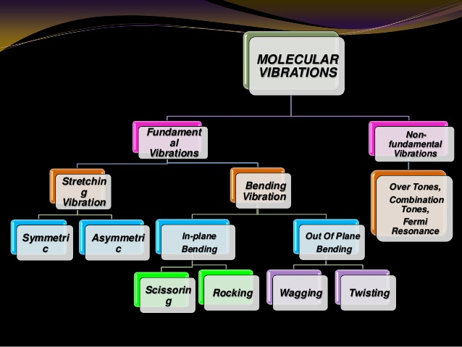

1. **Stretching:** in which the distance between the two atoms increases or decreases but the atoms remain in the same bond axis.

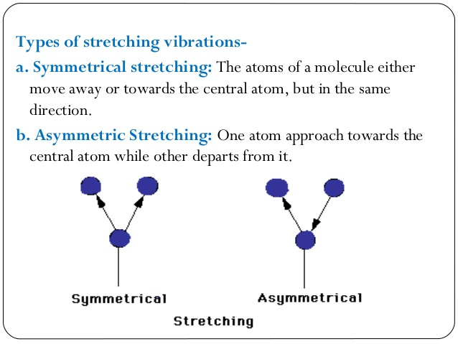

1. **Bending**: in which the position of the atom changes relative to the bond axis. Covalent bonds can vibrate in several modes, including stretching, rocking, and scissoring.

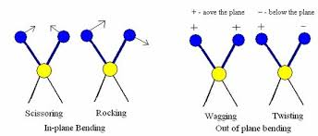

The various stretching and bending vibrations occurs at certain frequencies. When an IR radiation of same frequency is incident on the molecule, the energy is absorbed and the amplitude of that vibration increases correspondingly. When the molecule returns to ground state the absorbed energy released as heat.

A non-linear molecule containing n atoms has 3n-6 possible vibrational modes through which IR radiation may be absorbed. For example methane has 9 and benzene has 30 possible fundamental absorption bands respectively. In order that a particular vibration results in an absorption band, the vibration must cause change in the dipole moment of the molecule. A linear molecule has 3n-5 modes.

Stretching frequencies occur at higher frequency than the bending.

**Which substances give a signal in IR spectrum?**

**Ans:** The molecules that contain polar bonds i.e. molecules composed of

atoms of different elements, organic compounds and inorganic compounds (H2O,

CO2, NO2, HCl, salts...) can give a signal in IR spectrum. Whereas pure chemical elements in molecular or crystal state e.g. Ar, O2, O3, N2, Cl2, S8, silicon, graphite,

Diamond etc. cannot give a signal in IR spectrum.

Trans isomer is IR inactive while the cis isomer is IR active.

**Basic Principle:**

When a sample is placed in a beam of infrared radiation, the sample will absorb radiation at frequencies corresponding to molecular vibrational frequencies, but will transmit all other frequencies. The frequencies of radiation absorbed are measured by an infrared spectrometer, and the resulting plot of absorbed energy vs. frequency is called infrared spectrum of the material. Identification of a substance is possible because different materials have different vibrations and yield different infrared spectra. Furthermore, from the frequencies of the absorption it is possible to determine whether various chemical groups are present or absent in a chemical structure.

**Instrumentation of FTIR:**

The basic components of an FTIR are shown schematically in fig.



1. **The Source:-** Infrared energy is emitted from a glowing black body source. This beam passes through an aperture which controls the amount of energy presented to the sample (and, ultimately, to the detector).

2. **The Interferometer**:- The beam enters the interferometer where the “spectral encoding” takes place. The resulting interferogram signal then exits the interferometer.

3. **The Sample**:- The gaseous sample can be directly analysed. Liquid can also be used directly but in diluted form in NaCl plates. Solid compound can be mixed with KBr and formed a pallet and used.

The beam enters the sample compartment where it is transmitted through or reflected off of the surface of the sample, depending on the type of analysis being accomplished. This is where specific frequencies of energy, which are uniquely characteristic of the sample, are absorbed.

4. **The Detector**:- The beam finally passes to the detector for final measurement. The detectors used are specially designed to measure the special interferogram signal.

5. **The Computer**:- The measured signal is digitized and sent to the computer where the Fourier transformation takes place. The final infrared spectrum is then presented to the user for interpretation and any further manipulation.

**Working:**

The infrared source emits a broad band of different wavelength of infrared radiation. The IR source used is a SiC ceramic at a temperature of 1550 K. The IR radiation goes through an interferometer that modulates the infrared radiation. The interferometer performs an optical inverse Fourier transform on entering IR radiation. The modulated IR beam passes through the gas sample where it is absorbed to various extents at different wavelengths by the various molecules present. Finally, the intensity of the IR beam is detected by a detector, which is a liquid nitrogen cooled MCT (Mercury−Cadmium−Telluride) detector. The detected signal is digitised and Fourier transformed by the computer to get the IR spectrum of the sample gas.

**Factors affecting IR:**

1. Physical state of sample- Vapour absorbs at higher frequency than the solid or liquid. E.g.: cyclopentanone absorbs at 1772cm-1 in vapour state, 1742 in liquid state and at 1718 in solid state.
2. Electronic effects- Inductive and mesomeric effects play important role in the IR absorption. E.g.: HCHO at 1750cm-1, CH3CHO at 1745, CH3COCH3 at 1715.
3. H-bonding- Higher the H-bonding, the signal shifts to lower wavelength. Broad signal is observed in inter-molecular H-bonding. Sharp signal is observed in intra-molecular H-bonding.
4. Solvent effect- Solvent effect also plays important role in IR. E.g.: Position of signal for CO of acetone differs based on solvent used. In hexane CO is observed at 1726cm-1, in chloroform at 1713 and in ethanol at 1709.
5. Coupled vibrations and Fermi resonance also cause shifts in the signals.

**AN IR SPECTRUM IN ABSORPTION MODE:**

The IR spectrum is basically a plot of transmitted (or absorbed) frequencies

vs intensity of the transmission (or absorption). Frequencies appear in the x-axis in units of inverse centimetres (wavenumbers), and intensities are plotted on the y-axis in percentage units.



**AN IR SPECTRUM IN TRANSMISSION MODE:**



The graph above shows a spectrum in transmission mode. This is the most commonly used representation and the one found in most chemistry and spectroscopy books.

**CLASSIFICATION OF IR BANDS**

IR bands can be classified as strong (s), medium (m), or weak (w), depending on their relative intensities in the infrared spectrum. A strong band covers most of the y-axis. A medium band falls to about half of the y-axis, and a weak band falls to about one third or less of the y-axis.



Infrared band shapes come in various forms. Two of the most common are narrow and broad. Narrow bands are thin and pointed, like a dagger. Broad bands are wide and smoother.

A typical example of a broad band is that displayed by O-H bonds, such

as those found in alcohols and carboxylic acids, as shown below.



**INFORMATION OBTAINED FROM IR SPECTRA**

• IR is most useful in providing information about the presence or absence of specific functional groups.

• IR can provide a molecular fingerprint that can be used when comparing samples. If two pure samples display the same IR spectrum it can be argued that they are the same compound.

• IR does not provide detailed information or proof of molecular formula or structure. It provides information on molecular fragments, specifically functional groups.

• Therefore it is very limited in scope, and must be used in conjunction with other techniques to provide a more complete picture of the molecular structure.

**THE FINGERPRINT REGION**

Although the entire IR spectrum can be used as a fingerprint for the purposes of comparing molecules, the 600 - 1400 cm-1 range is called the fingerprint region.

This is normally a complex area showing many bands, frequently overlapping each other.

It is much more difficult to pick out individual bonds in this region than it is in the "cleaner" region at higher wavenumbers. The importance of the fingerprint region is that each different compound produces a different pattern of troughs in this part of the spectrum.



**FUNCTIONAL GROUPS AND IR TABLES:**

|  |  |  |  |  |  |  |
| --- | --- | --- | --- | --- | --- | --- |
| **Characteristic IR Absorption Frequencies of Organic Functional Groups** | | | | | | |
| **Functional Group** | **Type of Vibration** | | **Characteristic Absorptions (cm-1)** | | **Intensity** | |
| **Alcohol** |  | | | | | |
| O-H | (stretch, H-bonded) | | 3200-3600 | | strong, broad | |
| O-H | (stretch, free) | | 3500-3700 | | strong, sharp | |
| C-O | (stretch) | | 1050-1150 | | Strong | |
| **Alkane** |  | | | | | |
| C-H | Stretch | | 2850-3000 | | Strong | |
| -C-H | Bending | | 1350-1480 | | Variable | |
| **Alkene** |  | | | | | |
| =C-H | Stretch | | 3010-3100 | | Medium | |
| =C-H | Bending | | 675-1000 | | Strong | |
| C=C | Stretch | | 1620-1680 | | Variable | |
| **Alkyl Halide** |  | | | | | |
| C-F | Stretch | | 1000-1400 | | Strong | |
| C-Cl | Stretch | | 600-800 | | Strong | |
| C-Br | Stretch | | 500-600 | | Strong | |
| C-I | Stretch | | 500 | | Strong | |
| **Alkyne** |  | | | | | |
| C-H | Stretch | | 3300 | | strong, sharp | |
| http://www2.ups.edu/faculty/hanson/Spectroscopy/IR/IRalkyne.gif | Stretch | | 2100-2260 | | variable, not present in symmetrical alkynes | |
| **Amine** |  | | | | | |
| N-H | Stretch | | 3300-3500 | | medium (primary amines have two bands; secondary have one band, often very weak) | |
| C-N | Stretch | | 1080-1360 | | medium-weak | |
| N-H | Bending | | 1600 | | Medium | |
| **Aromatic** |  | | | | | |
| C-H | Stretch | | 3000-3100 | | Medium | |
| C=C | Stretch | | 1400-1600 | | medium-weak, multiple bands | |
| Analysis of C-H out-of-plane bending can often distinguish substitution patterns  Is 1,2,4 trisubstituted benzene active in the range 680~720 cm-1? | | | | | | |
| **Carbonyl** | [Detailed Information on Carbonyl IR](http://www2.ups.edu/faculty/hanson/Spectroscopy/IR/IRfrequencies.html#carbonylIR) | | | | | |
| C=O | Stretch | | 1670-1820 | | Strong | |
| (conjugation moves absorptions to lower wave numbers) | | | | | | |
| **Ether** |  | | | | | |
| C-O | Stretch | | 1000-1300 (1070-1150) | | Strong | |
| **Nitrile** |  | | | | | |
| CN | Stretch | | 2210-2260 | | Medium | |
| **Nitro** |  | | | | | |
| N-O | Stretch | | 1515-1560 & 1345-1385 | | strong, two bands | |
| **IR Absorption Frequencies of Functional Groups Containing a Carbonyl (C=O)** | | | | | | |
| **Functional Group** | | **Type of Vibration** | | **Characteristic Absorptions (cm-1)** | | **Intensity** |
| **Carbonyl** | |  | | | | |
| C=O | | Stretch | | 1670-1820 | | Strong |
| (conjugation moves absorptions to lower wave numbers) | | | | | | |
| **Acid** | |  | | | | |
| C=O | | Stretch | | 1700-1725 | | Strong |
| O-H | | Stretch | | 2500-3300 | | strong, very broad |
| C-O | | Stretch | | 1210-1320 | | Strong |
| **Aldehyde** | |  | | | | |
| C=O | | Stretch | | 1740-1720 | | Strong |
| =C-H | | Stretch | | 2820-2850 & 2720-2750 | | medium, two peaks |
| **Amide** | |  | | | | |
| C=O | | Stretch | | 1640-1690 | | Strong |
| N-H | | Stretch | | 3100-3500 | | unsubstituted have two bands |
| N-H | | Bending | | 1550-1640 | |  |
| **Anhydride** | |  | | | | |
| C=O | | Stretch | | 1800-1830 & 1740-1775 | | two bands |
| **Ester** | |  | | | | |
| C=O | | Stretch | | 1735-1750 | | Strong |
| C-O | | Stretch | | 1000-1300 | | two bands or more |
| **Ketone** | |  | | | | |
| Acyclic | | Stretch | | 1705-1725 | | Strong |
| Cyclic | | Stretch | | 3-membered - 1850 4-membered - 1780 5-membered - 1745 6-membered - 1715 7-membered – 1705 | | Strong |
| ,-unsaturated | | Stretch | | 1665-1685 | | Strong |
| aryl ketone | | Stretch | | 1680-1700 | | Strong |

**How to Analysis the IR spectrum?**

When analysing the IR spectrum of an unknown molecule, first efforts on determining the presence or absence of a few major functional groups. The C=O, O-H, N-H, C-O, C=C, , -CN, and NO2 peaks. These peaks are most conspicuous and give immediate structural information if they are present. Do not try to make a detailed analysis of the C-H absorption near 3000cm-1, almost all the compounds have these absorptions.

Follow the steps

1. **Is carbonyl group present ?** The –C=O group give rise to a strong absorption in the region 1820-1660cm-1 . The peak is often strongest in the spectrum and of medium width.
2. **If C=O is present**, then check the following types

|  |  |
| --- | --- |
| **Acids** | Is O-H also present? Broad absorption near 3400-2400cm-1 usually overlaps with C-H |
| **Amides** | Is N-H also present? Medium absorption near 3400cm-1, sometimes double peaks with same size. |
| **Esters** | Is C-O present? Strong intensity absorption near 1300-1000cm-1 |
| **Anhydrides** | Two C=O absorption near 1810 and 1760cm-1 |
| **Aldehydes** | Is aldehyde C-H present? Two weak absorption near 2850 and 2750 cm-1 |
| **Ketones** | The preceding five choices have been eliminated |

1. **If C=O absent,** then check the following options

|  |  |
| --- | --- |
| **Alcohols, Phenols** | Check for O-H, broad absorption near 3400-3300cm-1, confirm this by finding C-O near 1300-1000cm-1 |
| **Amines** | Check for N-H, Medium absorptions near 3400cm-1 |
| **Ethers** | Check for C-O near 1300-1000cm-1 and absence of O-H near 3400cm-1 |

1. **Double bonds and/or aromatic rings**

|  |
| --- |
| 1. C=C is weak absorption near 1650cm-1 |
| 1. Medium strong absorption in the region 1600-1450cm-1, these often imply on aromatic ring |
| 1. Confirm the double bond or aromatic ring by consulting the C-H region; aromatic and vinyl C-H occurs to left of 3000cm-1, aliphatic C-H occurs to right of this value. |

1. **Triple bonds**

|  |
| --- |
| 1. C N is medium sharp absorption near 2250cm-1 |
| 1. C C is weak, sharp absorption near 2150cm-1 |
| 1. Check also for acetylenic C-H near 3300cm-1 |

1. **Nitro groups**

|  |
| --- |
| Two strong absorption at 1600-1530cm-1 and 1390-1300cm-1 |

1. **Hydrocarbons**

|  |
| --- |
| None of the preceding found. |
| Major absorptions are in C-H region near 3000cm-1 |
| Very simple structure the only another absorption appear near 1460 and 1375cm-1 |

**IR spectrum of n-Hexane**



**IR spectrum of 1-Hexene**



**IR spectrum of 1-Octyne and 4-Octyne**



**IR spectrum of Butyronitrile**



**IR spectrum of 1-Butnol**



**IR spectrum of 1-Butanal and 2-Heptanone**



**IR spectrum of n-Hexanoic acid**



**IR spectrum of 1-Butanamide**



**IR spectrum of 3-Bromoaniline**



**1H NMR spectroscopy**

**Theory & Principle of NMR:**

In the late 1940’s, physical chemists originally developed NMR spectroscopy to study different properties of atomic nuclei, but later found it to be useful in determining the molecular structure of organic compounds.

The theory behind NMR comes from the spin, I of a nucleus. Just as electrons have a +1/2, -1/2 spin, certain nuclei also experience charged spins that create a magnetic field (called the magnetic moment), which allows chemists to study them using NMR. Nuclei with even numbers of both neutrons and protons experience NO spin and nuclei with odd numbers of both neutrons and protons have integer spins. Nuclei that have the sum of protons and neutrons equal to an odd number (like 1 H and 13C) have half-integer spins.

When there is no external or applied magnetic field (B0), the nuclear spins orient randomly; however, when there is an applied magnetic field, the nuclei orient themselves with or against the larger applied field. The α-spin state is parallel to the applied force and has lower energy than the β- spin state that is antiparallel to the applied force. The energy difference (δE) between the α- and β-spin states depends on the strength of the applied magnetic field. The greater the strength of the applied magnetic field, the greater is the δ E between the α- and β-spin states. The δ E between the α- and β-spin state is ~0.02 cal mol-1, which lies in the radio frequency region. The emitted energy in this region produces an NMR signal.



**Instrumentation:**

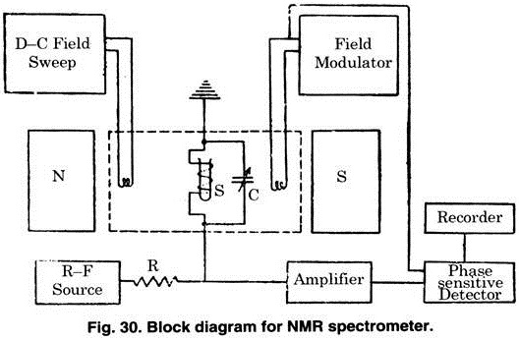

The block diagram for a sample NMR spectrometer is shown in Fig. In block diagram, the blocks labelled N and S represent the poles of the large HO magnet, which is generally an electromagnet operated through a stabilized power supply. A field of up-to 1400 gauss and a pole of about 1.75 — 1.8 inch is necessary for high resolution spectra. The frequency and field strength are related to each other by Larmor condition.

v = үHO/2π

[This equation represents the condition of resonance.]

where HO = magnetic field,

v = is the frequency of radiation associate with transition from one state to another. It is generally known as Larmor frequency,

ү = proportionality constant or gyromagnetic ratio.

**NMR Spectrum**



The NMR spectrum is plot of intensity of NMR signal versus the magnetic field frequency in reference to TMS. The intensity is measured by integration of area under the triangles.

**Interpreting 1H NMR Spectra:**

The Information’s obtained from 1H –NMR are:

1. **Number of signals:** Protons within a compound experience different magnetic environments, which give a separate signal in the NMR spectrum.

* Equivalent Protons that reside in the same magnetic environment are termed chemically equivalent protons.

Examples, As a general rule of thumb, H’s in CH3 and CH2 groups are usually

equivalent. Symmetrical compounds, such as benzene, are also equivalent.

* However, since many compounds are not symmetrical, it is important to know how to identify nonequivalent protons. Protons that are different in any way (even in their stereochemistry) are not equivalent and will absorb at different frequencies (give a separate signal on the NMR spectra).



1. **Position of signals (chemical shift):**

The position on the horizontal frequency scale at which the equivalent proton signals occur (δ E) is called a chemical shift (measured in δ ppm). Protons generally sense 3 different magnetic fields: magnetic field of the Earth, the NMR spectra, and different protons in the molecule. Since the magnetic fields of the Earth and NMR spectra are felt similarly by all the protons in the molecule, the chemical shift depends only on the varying local magnetic fields from the neighboring protons.

The chemical shift parameter δ is defined

δ = (Hr – Hs)/Hr × 106 ppm

where Hr and Hs are field strengths corresponding to resonance for a particular nucleus in the sample (Hs) and reference (Hr).

But as spectra are usually calibrated in cycles per second (cps), the equation can be written as:

δ = ∆v × 106/Oscillator frequency (cps)

where ∆v = Difference in absorption frequencies of the sample and the reference in cps; oscillator frequency is the characteristic of the instrument: For a 60 MHz instrument, the oscillator frequency is 60 × 106 cps.

The factor 106 has been included for convenience.

1. **Reference compound: Tetramethylsilane (TMS)**

In order to standardize the NMR spectra, the chemical shifts are positioned in relation to a reference proton set at 0.00 ppm. Tetramethylsilane, (CH3)4Si, is the standard for 1H NMR. TMS is practical as a reference compound because of its inert quality that prevents it from reacting with the sample and its highly volatile nature that makes it easy to evaporate out of samples. Few compounds have a lower frequency reading than TMS and it has 12 equivalent protons that read strongly on the NMR spectra.



1. **Shielding effects:**

Under an applied magnetic field, circulating electrons in the electron cloud produce a small opposing magnetic field, ultimately decreasing the effective magnetic field felt by the proton, shifting the signal to the right (or upfield). This effect, in which the electron cloud “shields” the proton from the applied magnetic field is called local diamagnetic shielding.

1. **Electronegativity and deshielding**:

Hydrogen atoms that are attached to more electronegative atoms experience higher chemical shifts. Electronegative atoms also remove electrons from the electron cloud, which decreases their density and results in less shielding; hence electronegative atoms are said to deshield the proton and cause it to have a higher chemical shift, moving it to the left (or downfield). The magnitude of the deshielding effect, however, rapidly decreases as the distance between the proton and electronegative atom increases (refer to NMR spectrum diagram above).

Examples: Literature values of the methyl chemical shift as it moves away from bromine



1. **Relative Intensity of Signals (Integration):**

The area under the signals (integration) corresponds to the number of protons responsible for that signal. Therefore, the relative intensities of the signal are proportional to the relative number of proton equivalents. It is important to remember that integration only provides ratios of protons, not the absolute number. For convenience in calculating the relative signal strengths, the smallest integration is set to 1 and the other values are converted accordingly.



1. **Splitting of signals (spin-spin coupling):**

NMR signals are not usually single triangles, but a complex pattern of split triangles labeled as doublets (2 peaks), triplets (3 peaks), quartets (4 peaks), etc. The distance between the split peaks are called coupling constants, denoted by J13. The interaction between nearby protons produce different spin flip energies (_ E) as they can orient themselves in a pattern of parallel or antiparallel to the applied magnetic force. This phenomenon, where the spin of the nucleus of one proton is close enough to affect the spin of another, is called spin-spin coupling. Splitting is always reciprocated between the protons—if Ha splits Hb, then Hb must split Ha—and provides information on the neighbors of a proton within the molecule.



**Factors affecting the chemical shift:**

Actually the chemical shift parameter δ is a function of electron density around the nucleus as the electrons are directly involved in the diamagnetic shielding which acts to attenuate the applied magnetic field. Hence following factors are responsible for influencing its value:

(a) Specific solvent,

(b) Bulk diamagnetic susceptibility effect,

(c) Temperature (only when change in temperature causes changes in some type of association equilibrium or changes in amplitude of torsional vibrations),

(d) Electron density,

(e) Inductive effect,

(f) Vander Waal deshielding, and

(g) Hydrogen bonding.

**The spectrum gives several kinds of information:**

(1) The number of signals (peaks) tells us how many kinds of protons (protons with different chemical environments) are present in a molecule.

(2) The position (chemical shift) of the signal informs about the bonding environment of each proton.

(3) The area under each signal tells us how many protons of each kind are in the molecule.

(4) All hydrogens with identical environments in a molecule have same chemical shift, e.g., (a) all the three protons of a methyl CH3; (b) the protons of a methylene — CH2; (c) one identical.

(5) Protons on heteroatoms (H—S, H —N, H—O etc.) show highly variable chemical shifts and sometimes broad peaks.

(6) Hydrogen on different carbons yields the same absorption signal if they are structurally indistinguishable.

(7) Sometimes a proton exhibits an absorption signal which is split into several peaks because of coupling with its neighbouring protons. In such cases a coupling constant J is calculated.

(8) The number of peaks (N) into which a proton signal is split equals one more than the number of vicinal protons (n) (number of equivalent neighbours causing splitting):

N = n + 1

N = 2 (one vicinal H) = doublet (d)

= 3 (two vicinal H’s) = triplet (t)

= 4 (three vicinal H’s) = quartet (q).

**Applications of N.M.R. Spectroscopy:**

(1) Quantitative Analysis: The area of peak is directly proportional to the number of nuclei responsible for that peak. Thus the concentration of species can be determined directly by making use of signal area per proton. The signal area per proton can easily be calculated by use of a known concentration of an internal standard.

Similarly, (the concentration of new species formed during the reaction can also be calculated from the spectrum of parent compound.

(2) Qualitative Analysis: The qualitative analysis of the compound can easily be made by knowing:

(i) Chemical shift 8 values of hydrogen containing groups,

(ii) The presence of particular functional group,

(iii) The relative position of these groups and

(iv) The relative number of nuclei in these groups.

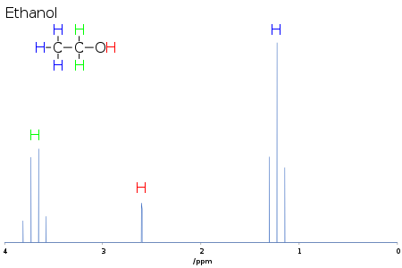

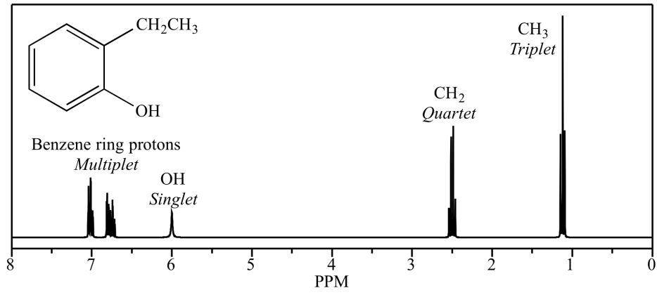

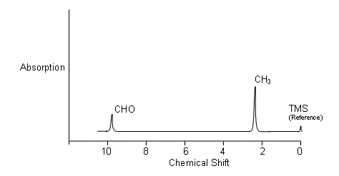

**ELECTRO-ANALYTICAL TECHNIQUES**

**pH Metry**

**Definition of pH**

pH is an abbreviation of “pondus hydrogenii” and was proposed by the Danish scientist S.P.L. Sørensen in 1909 in order to express the very small concentrations of hydrogen ions.

In 1909, pH was defined as the negative base 10 logarithm of the hydrogen ion concentration. However, as most chemical and biological reactions are governed by the hydrogen ion activity, the definition was quickly changed. As a matter of fact, the first potentiometric methods used actually resulted in measurements of ion activity.

The definition based on hydrogen ion activity is the definition we use today:

pH = - log10aH+

**pH Theory:**

pH is measured using a setup with two electrodes: the indicator electrode and the reference electrode. These two electrodes are often combined into one - a combined electrode. When the two electrodes are immersed in a solution, a small galvanic cell is established. The potential developed is dependent on both electrodes. Ideal measuring conditions exist when only the potential of the indicator electrode changes in response to varying pH, while the potential of the reference electrode remains constant.

The measured voltage can be expressed by the Nernst equation in the following way:

E = Eind - Eref = E'T - R • T/F • lnaH+

where

E = Measured voltage (mV)

Eind = Voltage of indicator electrode (mV)

Eref = Voltage of reference electrode (mV)

E'T = Temperature dependent constant (mV)

R = Gas Constant (8.3144 J/K)

T = Absolute Temperature (K)

F = Faraday's constant (96485 C)

By using the base ten logarithm, the formula can be written as:

E = E'T - 2.303 • R • T/F • log aH+

By introducing the pH definition as pH = -log aH+, pH can be expressed at the temperature T as follows:

pHT = pHT° - ____E_____

R' • S • T

where

R' = constant = 0.1984 mV/K

S = sensitivity, a correction factor which takes into account that the electrode response may differ from the theoretical value.

pH° = zero pH which is defined as the pH value at which the measured potential is zero.

**Working of pH- meter**

A pH meter measures the potential difference (in mV) between the electrodes and converts it to a display of pH.

In order to obtain a correct measurement, the input amplifier and the converting circuit must meet certain requirements. The principal construction of a pH meter can be seen in the simplified diagram below.



The potential difference between the reference electrode and the glass electrode is amplified in the mV amplifier before the A/D converter feeds the signal to the microprocessor for result calculation. To attain reliable and consistent results, the amplifier and other circuits must have a small temperature coefficient, i.e. the influence of temperature variations must be under control.

Normally, the result is displayed in numeric form although a few pH meters with pointers are still available. The term analog or digital pH meter is often used to distinguish between these two forms of display. However, it is also used to differentiate between control convert circuitry in analog or digital form.

In an analog pH meter, the adjustment of zero pH and sensitivity is carried out using adjustable resistances (dials) and the amplification factor is under direct manual control. The signal is then sent through an A/D converter. The output is a digital signal for the numeric display.

In a digital pH meter, the amplifier works under the same conditions all the time and is directly connected to an A/D converter. The converter's output is then manipulated by digital circuitry (microprocessor-based) and the calculated pH is then displayed. Use of a temperature sensor provides both temperature correction and a temperature display.

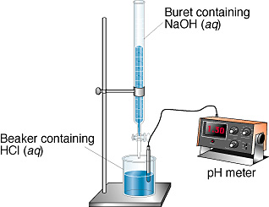

**To Measure pH of solution i.e. Measurement of pH:**

A pH measurement system consists of a pH probe, reference probe, temperature sensor, pH meter and the sample to be measured. In most cases the three probes are combined in one electrode. When the pH probe is in contact with a solution a potential forms between the pH probe and the reference probe. The meter measures the potential and converts it, using the calibration curve parameters, into a pH value.

A typical combination glass electrode is represented as

 In order to measure the pH of a sample first the standardization of pH meter is required to be done before analyzing the sample.

1. Standardization of pH meter:

A two point standardization method is used to standardize the pH meter, it involves immersing the pH assembly i.e. glass electrode into a standard reference pH buffer (pH =4.0) and recording the reading, if the meter reading is more or less than the expected value (4.0) then it is adjusted to pH 4.0 using a crew nob.

Standardization at only one pH value does not assure the validity of reading at other pH values considerably. Hence a second standard reference buffer pH = 9.2 is used. The pH meter reading is recorded using this second buffer solution and the reading is adjusted to pH 9.2 using a crew nob.

During both the steps, the glass electrode is rinsed with distilled water. Immerse the glass electrode previously in water for several hours. Start the measurement more than 5 minutes after switching on. Rinse well the detecting unit with water, and blot the water gently with a piece of filter paper very time.

1. To measure pH of solution:

Wash well the detecting unit with water, and blot the water gently with a piece of filter paper. Place glass electrode in solution you wish to measure pH. Be sure that it is stirring slowly during measure and pH adjustment and take readings.

1. Precautions:

When analysis is complete, put pH meter in stand-by mode. Remove electrode from solution and rinse thoroughly with water. Blot dry and put back in yellow pH storage buffer. Place parafilm over the hole and around the bottle to minimize evaporation.



**Advantages of pH Meter**

1. pH Meter is inexpensive and robust. 2. Pocket size pH Meters are user friendly. 3. Readings are accurate and precise.

**Disadvantages of pH Meter**

1. Temperature impacts the output readings. 2. pH Meter using glass electrodes must be clean as deposition on the electrodes affects the readings.

**Glass Electrode:**

**Construction:** It consists of a glass bulb membrane, which gives it its name and an electrically insulating tubular body, which separates an internal solution and a silver/silver chloride electrode from the studied solution. The Ag/AgCl electrode is connected to a lead cable terminated with some connector that can hook up to a special voltmeter, the pH meter. It is represented as

Ag/AgCl | HCl | glass || probed solution | reference electrode

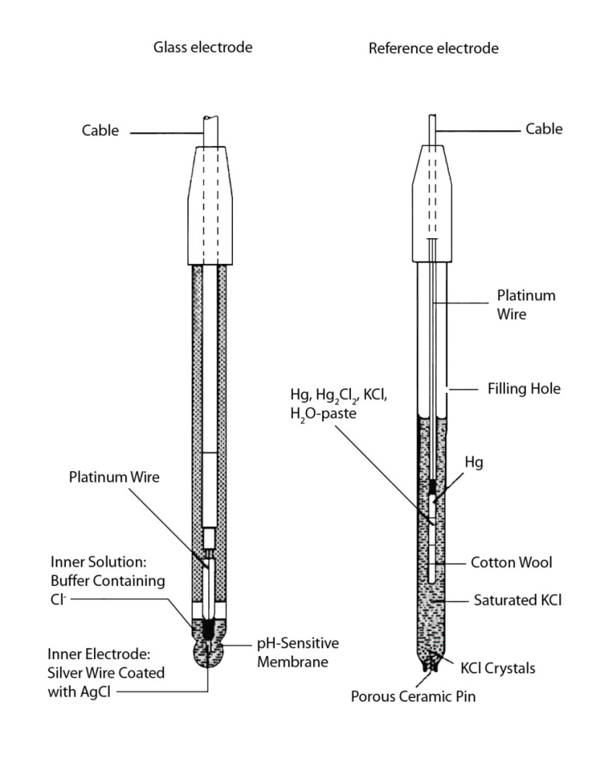

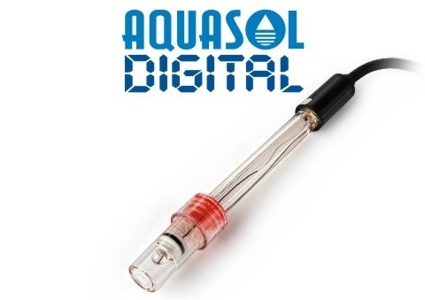 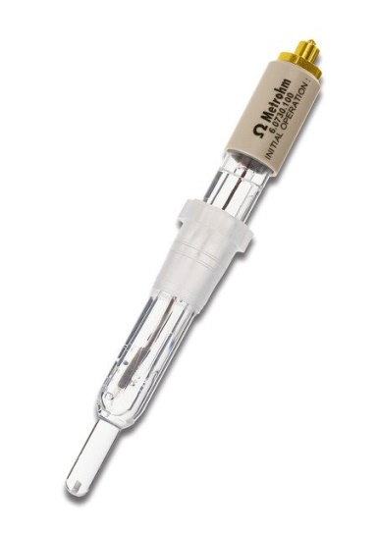

Glass electrode indicator electrode Ag/AgCl reference electrode

**Working:** The pH meter measures the potential difference and its changes across the glass membrane. The potential difference must be obtained between two points; one is the electrode contacting the internal solution. A second point is obtained by connecting to a reference electrode, immersed in the studied solution.

The potential difference relevant to pH measurement builds up across the outside glass/solution interface.

Eglass wall/solution = Eo - RT/2.303F log a(H3O+)

Where R is the molar gas constant 8.314 J mol-1 K-1, T is the temperature in kelvins, F is the Faraday constant 96,485.3 C

Eglass = E0 – 0.59 x log[H+]

**Reference Electrode:**

The reference electrode is a silver wire coated with silver chloride in contact with a defined electrolyte solution, see above figure. In many reference electrodes a gel is used instead of a liquid as the internal filling. These gels also contain KCl to maintain the reference potential and add sufficient conductivity. As described in 2.2 the reference potential is constant as long as the internal electrolyte is constant. The reference potential also varies slightly with temperature.

The tube containing all the reference elements and solutions/gel is in contact with the sample to measure through a junction (diaphragm). It is essential to maintain a free flow of ions through the junction. Otherwise the reference electrode will not respond properly to pH changes in the sample.

Eref = E0 – 0.59 x log[Cl-]

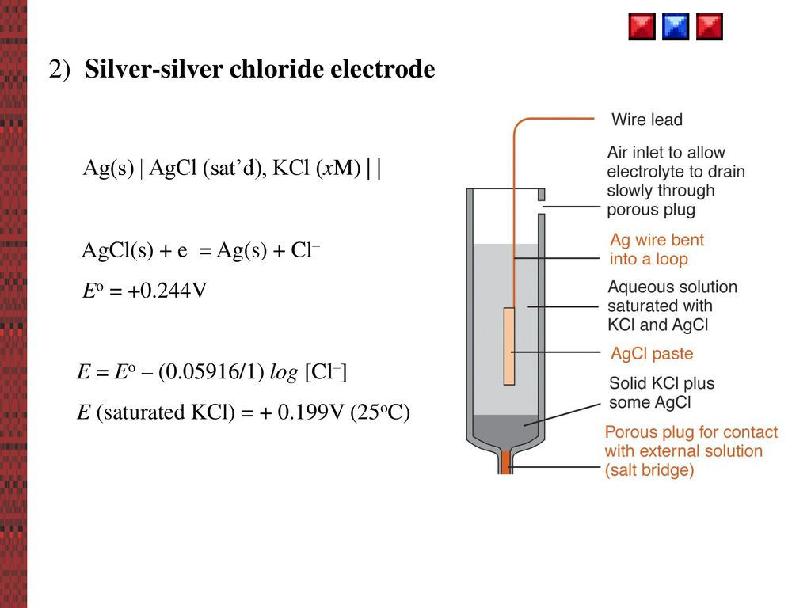

**Combination Electrode:**

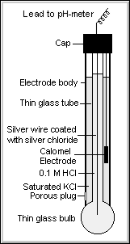 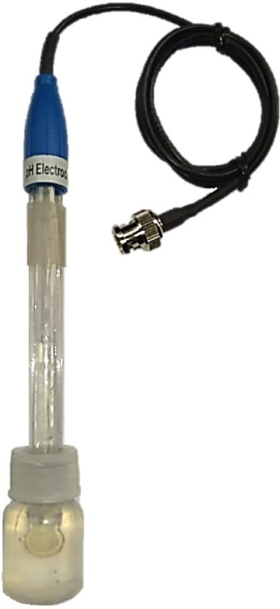

**Construction:** The fig. shows the internal components of the pH electrode. The heart of the electrode is a thin bulb of pH-sensitive glass, which is blown onto the end of a length of glass tubing. The pH-sensitive glass (glass membrane) is sealed to the electrode and contains a solution of potassium chloride at pH 7. A silver wire plated with silver chloride contacts the solution. The Ag/AgCl combination in contact with the filling solution sets an internal reference potential. This potential depends on the chloride concentration in the filling solution and as long as this electrolyte concentration is maintained, the electrode potential is constant.

**Working:** The outside surface of the glass membrane is in contact with sample being measured and the inside surface contacts the filling solution. A complex mechanism at each glass liquid interface defines the potential the pH glass electrode, while the inner pH glass/ filling solution potential is constant, the outside potential varies based on the H+ ions concentration in sample. This equilibrium depends also on temperature.



**Conductometry**

Conductometry is general method, where two electrode systems are used for simultaneous measurement of all electroactive compounds in a solution. It is a measurement of electrolytic conductivity to monitor a progress of chemical reaction.

**Conductometric Titration:**

Conductance is a property of solutions of electrolytes. It is the measure of the number of ions present in the solution, as well as the current carrying capacity of the ions. When the solution contains one single electrolyte, the measured conductance of the solution can be related to concentration of the electrolyte.

Conductometric titration is a type of titration in which the electrolytic conductivity of the reaction mixture is continuously monitored as one reactant is added. The equivalence point is the point at which the conductivity undergoes a sudden change. Marked increases or decrease in conductance are associated with the changing concentrations of the two most highly conducting ions—the hydrogen and hydroxyl ions. The method can be used for titrating coloured solutions or homogeneous suspension e.g.: wood pulp suspension, which cannot be used with normal indicators.

**Principle:**

When solution of one electrolyte is added to another electrolyte without appreciable volume change, the conductance of the solution will alter, if an ionic reaction occurs. If no ionic reaction takes place then the conductance of the solution will simply increase. On the other hand, if an ionic reaction occurs, the ion added may replace another ion and hence bring about change in the conductance.

Let A+B- be the ions of titrand and C+D- be ions of the titrant, the ionic reaction in the titration is combination of A+ and D-, AD formed may be insoluble or weakly ionized.

A+B- + C+D- 🡪 AD + C+B-

Thus as the titration proceeds, A+ are replaced by C+. the conductance of the solution increases or decreases depending on whether conductance of C+ is greater than or less than that of A+. After equivalence point the ionic reaction does not occur and hence, the conductance of the solution will rise due the excess addition of titrant C+D-.

The principle of conductometric titration is, changes in the conductance of the solution due to difference in the ionic conductance or due to production of more number of ions in the solution. Both factors permit, location of the equivalence point by conductance measurements.

**Procedure:**

A definite volume of the solution to be estimated is pipetted out in a beaker. A dip type conductivity cell is place in a beaker. Addition of distilled water may be necessary if the cell does not dip completely in the solution. The cell is connected to a conductometer and the conductance of the solution is measured. The titrant is filled in the burette. The titrant is added in the small portions, generally 0.5 mL at a time. The solution is stirred after each addition. The solution is allowed to stand for a minute or two after stirring before conductance is measured. Addition of titrant is continued till about seven to eight readings beyond the equivalence point are obtained. The plot of conductance against volume of the titrant added is used to locate the equivalence point.

**Titration Curves**:

Some Typical Conductometric Titration Curves are:

1. **Strong Acid with a Strong Base**, e.g. HCl with NaOH: Before NaOH is added, the conductance is high due to the presence of highly mobile hydrogen ions. When the base is added, the conductance falls due to the replacement of hydrogen ions by the added cation as H+ ions react with OH − ions to form undissociated water. This decrease in the conductance continues till the equivalence point. At the equivalence point, the solution contains only NaCl. After the equivalence point, the conductance increases due to the large conductivity of OH- ions



1. **Weak Acid with a Strong Base, e.g. acetic acid with NaOH:** Initially the conductance is low due to the feeble ionization of acetic acid. On the addition of base, there is decrease in conductance not only due to the replacement of H+ by Na+ but also suppresses the dissociation of acetic acid due to common ion acetate. But very soon, the conductance increases on adding NaOH as NaOH neutralizes the un-dissociated CH3COOH to CH3COONa which is the strong electrolyte. This increase in conductance continues raise up to the equivalence point. The graph near the equivalence point is curved due the hydrolysis of salt CH3COONa. Beyond the equivalence point, conductance increases more rapidly with the addition of NaOH due to the highly conducting OH-ions.



1. **Strong Acid with a Weak Base, e.g. sulphuric acid with dilute ammonia**: Initially the conductance is high and then it decreases due to the replacement of H**+**. But after the endpoint has been reached the graph becomes almost horizontal, since the excess aqueous ammonia is not appreciably ionised in the presence of ammonium sulphate.



1. **Weak Acid with a Weak Base**: The nature of curve before the equivalence point is similar to the curve obtained by titrating weak acid against strong base. After the equivalence point, conductance virtually remains same as the weak base which is being added is feebly ionized and, therefore, is not much conducting.



1. **Mixture of a Strong Acid and a Weak Acid vs. a Strong Base or a Weak Base**: In this curve there are two break points. The first break point correspondsto the neutralization of strong acid. When the strong acid has been completelyneutralized only then the weak acid starts neutralizing. The second break pointcorresponds to the neutralization of weak acid and after that the conductanceincreases due to the excess of OH−ions in case of a strong base as the titrant. However, when the titrant is a weak base, it remains almost constant after the end point similar to Fig.



**Conductometric titration of a mixture of a strong acid (HCl) and a weak**

**acid (CH3COOH) vs. a strong base (NaOH) or a weak base (NH4OH)**

**Advantages of Conductometric titrations**:

Conductometric titration are found to possess several advantages over normal titrimetry namely,

1. Coloured solutions can be titrated.
2. The method works equally well for dilute solutions also, as it is based on the changes in the conductance, rather than the absolute value of the conductance.
3. In conductometric titrations, it is not necessary to make observations around the equivalence point, with small increments of the titrant added. The observations, far away from the equivalence point, on either side are of importance.
4. An extremely weak acid or a weak base can be titrated conductometrically, which may not be possible in normal titrimetry.
5. A mixture of weak and strong acids, can also be titrated with relative ease. Thus, making the simultaneous determination possible.

**Limitations:**

1. In dilute solutions, obtuse curves are obtained. With obtuse curves it is difficult to locate the equivalence point accurately.
2. The overall accuracy of the conductometric titrations is limited as the technique does not permit addition of small increments of the titrant.